Integration between local and remote GIT repository: GitHub has imposed restriction on pushing any changes to remote repository. The authentication between local and remote repository is allowed only using SSH key authentication method.

To add SSH key authentication, public key from local machine where the local repository resides should be shared on the remote repository at GitHub.

This can be done on a remote repo, in this example ganeshhp/helloworldweb,

1. select settings
2. Click on ‘Deploy keys’
3. Click on ‘Add Deploy Key’
4. Copy the .pub file conetnts into the GPG key section.



The above process will help to set authentication between local and remote repository, but this will work for the selected remote repository only.

Now, if we want to set authentication for all the local repositories created on local machine, with the respective remote repository on the remote GitHub account, the keys should be shared in access section on the User profile page as shown in the above screenshot.

This option shows sharing the SSH Keys globally whereas the earlier option shows SSH keys shared locally for a specific repository only.

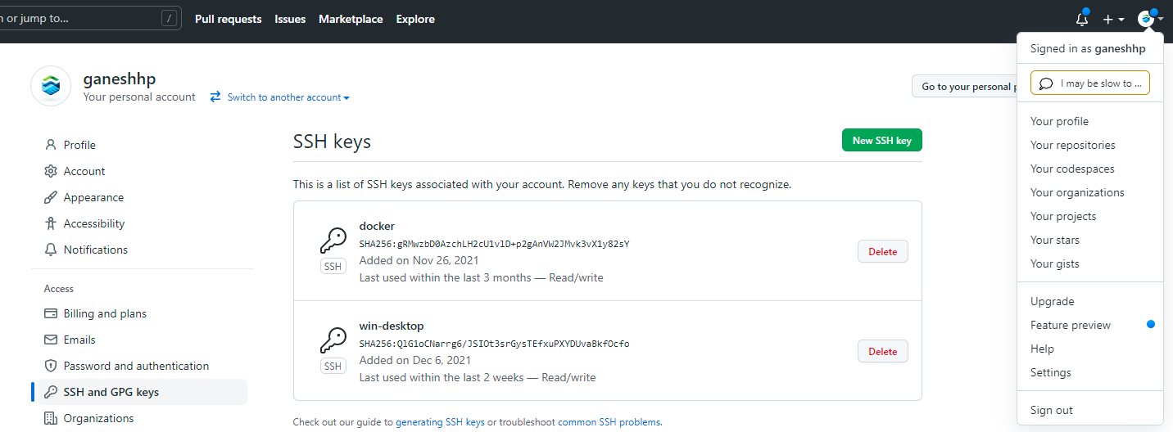

1. Click on the user profile section.
2. Click on the settings.
3. Under user profile click on SSH and GPG Keys.
4. Click on New SSH keys.
5. Copy the .pub key to the add deploy page pages.